

**JOB TITLE:**

Team Leader

**RESPONSIBLE TO:**

Home Manager

**PROFILE:**

To be responsible to the Home Manager as a member

of the staff team for the direct day-to-day care of the

children and young people and other supportive tasks

and duties.

**MAIN DUTIES**

**Caretech Values**

* To ensure that you demonstrate commitment towards the Caretech Values and Care Tech Children’s Services key mission statement:
* **Mission Statement: ‘*tytyatydtydta***

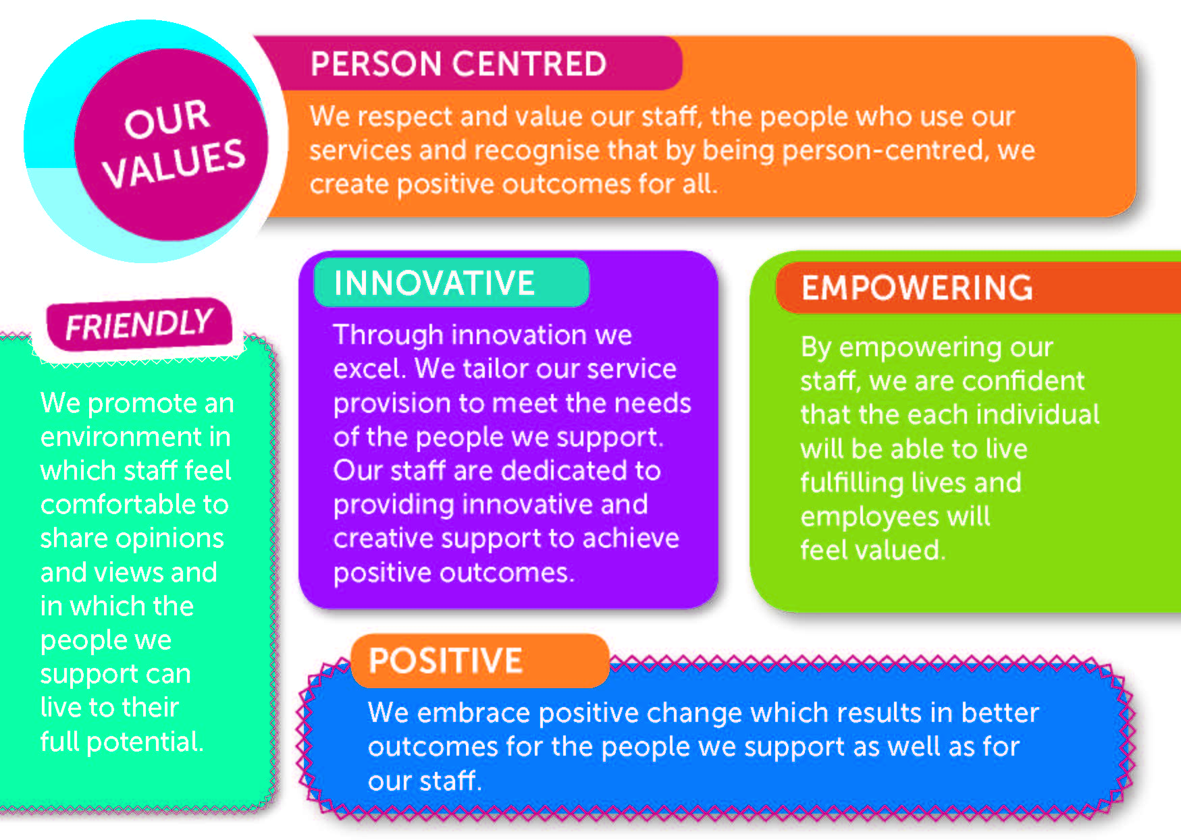

**Professional Child Care Practice**

* To provide primary basic care and a nurturing, therapeutic environment to help the child progress.
* Manage the home effectively in the absence of the home manager &/ or deputy/trainee manager.
* Effectively lead shifts, direct and support the staff team.
* To supervise staff and manage individual and team performance to ensure a standard of excellent service delivery.
* Ensure the effective monitoring and control of all expenditure accounted for in accordance with financial procedures.
* To manage health and safety processes in the home including implementation and monitoring of risk assessments.
* To support the induction process of new staff.
* To model a robust commitment to safeguarding actively promoting the welfare of children and young people in Branas Isaf & Caretech.
* To contribute to the normal development of the children and young people through the provision of a healthy lifestyle to enable them to reach their fullest potential by providing a variety of stimulating activities and a consistent and caring adult model.
* To work with consistent boundaries in order to create safety for the children and young people.
* To be a positive role model for the children, young people and colleagues and encourage them to develop meaningful relationships and attachments.
* To be alert to signs of distress or abuse and to ensure that the children and young people are monitored and protected and have their needs met ensuring that all safeguarding needs are met.
* To be aware of the children’s rights and to work in an anti-discriminatory and anti- oppressive manner.
* To work alongside the children and young people to help develop a true sense of identity and feeling of self-worth.
* To be sensitive to the needs of individual children and young people, taking account of race, culture, language, sexuality and religion.
* To engage, communicate, talk and listen to the children and young people. To observe their behaviour and record significant features.
* To liaise where necessary with other professionals i.e. schools, social workers.
* To support the children and young people to integrate into social activities and where appropriate educational settings mainstream school.
* To use strategies to support the behaviour of children and young people who are unable to manage their own behaviour.
* To assist in preparation for reviews and placement planning/ care planning meetings and attend and participate in meetings when required.
* To contribute to placement and care planning and the implementation of these plans.
* To work alongside psychologists, therapists and education staff to enable effective integration of care, therapy and education.
* To work with children and young people and their prospective carers to ensure the child’s successful integration into a family when placed.
* To be a key carer of a child or young person where designated.

**Relationships with Colleagues**

* To act as a member of the staff team, supporting colleagues and being prepared to receive support and advice as necessary.
* To participate in team meetings at regular intervals.
* To communicate and work professionally with colleagues, including other members of the Branas Isaf integrated team (therapy/ education).
* To communicate and work professionally with colleagues within the wider Caretech organisation,
* To act flexibly, within reasonable bounds in order to ensure the necessary outcomes for children and young people.
* To ensure effective outcomes for children and young people.

**Household Responsibilities**

* To share in the practical activities necessary to maintain the home to the highest standard.
* To set the highest standard in home making.
* To take ownership of the home, including the fabric, equipment and grounds.
* To be accountable for monies allocated for specific purposes where appropriate.
* To ensure the children have a nutritious balanced diet.
* To adhere to Health and Safety Regulations and Procedures.

**Personal**

* To keep abreast of good practice and legislation in order to develop skills, knowledge and experience, in accordance with your personal development plan.
* To be able to take responsibility for own personal development.
* To make use of regular supervision & appraisal.
* To develop an understanding of Branas Isaf/ Caretech Whistle Blowing Policy and procedure.
* To attend in-house and external training to develop skills, knowledge and experience.
* To commit to ongoing personal and professional development.

***Social Care Wales- Code of Professional Practice for Social Care***

*For any staff working in Wales it is a requirement to be accepted and registered onto The Social Care Wales Code of Professional Practice for Social Care Register.* The Code is the primary document setting out the standards for conduct and practice. It also forms part of the wider package of legislation, practice standards and employers’ policies and procedures that social care workers must meet.

As a social care worker you are responsible for making sure that you work to the standards in the Code. You must ensure that your conduct and practice do not fall below the standards, and that no action or omission on your part harms the well-being of individuals.

The Code of Professional Practice for Social Care (Wales) is available at <https://socialcare.wales/resources/code-of-professional-practice-for-social-care>

SIGN:...........................................................................................

PRINT:..........................................................................................

DATE:………………………………………………………………….