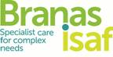

**JOB TITLE:**

Home Manager (England)

**RESPONSIBLE TO:**

Head of Service

**PROFILE:**

To ensure that the Home meets the standards and expectations of its Statement of Purpose. To safeguard and promote the welfare of children and to ensure that the quality of care provided is consistent with the Children Homes Regulations and the Quality Standards. To establish and maintain a competent, motivated and confident staff team and to offer leadership, managerial direction, guidance and support to staff at all levels. To ensure that the Home’s policies and procedures are adhered to and that resources are managed effectively. To develop systems for the efficient administration of the Home and to ensure that the fabric of the Home, equipment, appliances and grounds are maintained to the highest order in accordance with Health and Safety requirements. To be the responsible person in managing child protection concerns and complaints. To ensure close positive and professional working relationships with all other members of the Branas Isaf integrated multi-disciplinary team. To liaise with Local Authorities, School, Health and other professionals to achieve best outcomes for young people. To actively promote the Home’s equal opportunity and anti-discriminatory practice policies

**MAIN DUTIES**

**Caretech Values**

* To ensure that you demonstrate and promote commitment towards the Caretech Values and Care Tech Children’s Services key mission statement:
* **Mission Statement: ‘*tytyatydtydta***

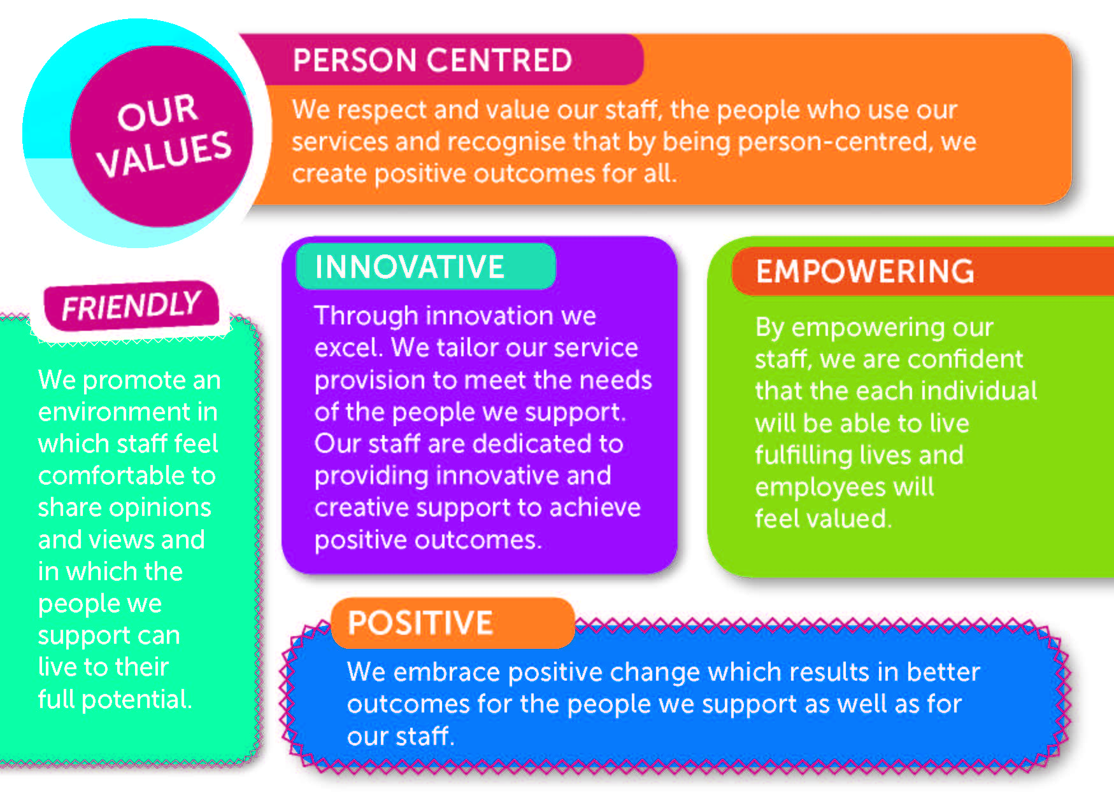

**MAIN DUTIES**

**Managing service delivery**

* To fulfil the role of the Registered/ Home Manger as defined within the Care Standards Act, this may include travel within the UK.
* To deliver on the content of the Certificate of Registration and the Statement of purpose for the establishment.
* To protect children and young people from risks to their health, welfare and normal development, both inside and outside the home.
* To ensure that the environment is managed in line with all Health and Safety requirements and that this is reflected in monitoring, reporting and recording functions.
* To ensure the home environment is appropriate and sensitive to the needs of the children and young people being looked after and is compliant with the Children’s Homes Regulations 2015 and the Quality Standards for Children’s Homes.
* To use the residential experience as a means of support and social learning for children and young people.
* To actively promote the involvement of all children and counter isolation of individuals by others.
* To ensure key stages in the stay of children and young people such as admission and discharge are properly managed, and reflect decisions recorded in care plans.
* To ensure that children facing particular crisis and stresses are offered appropriate additional support, and to ensure that staff are supported in dealing with the most complex cases.
* To participate in the development, implementation and monitoring of individual children’s care plans.
* To develop and maintain good working relationships with parents and other family members; social workers; school staff and other professionals with a concern for the children’s needs such as general practitioners or psychologists.
* To ensure that specific needs are met, such as dietary requirements, religious observance and culturally significant activities.
* To encourage and support children and young people to take responsibility for their own lives commensurate with their age and ability.
* To ensure compliance with the Children’s Homes Regulations (2015) and the Quality Standards.
* To ensure children and young people realise their full potential in line with the Quality Standards
* Ensuring that each young person has a plan which reflects his / her care, education, social, emotional, cultural, therapeutic and health needs and that this plan is regularly reviewed.
* Allocating a Key Worker for each young person with the principal responsibility of implementing the childcare plan.
* Establishing and monitoring high quality standards of care in line with Quality Standards and the Home’s Statement of Purpose and developing quality assurance measures to ensure these standards are maintained.
* Developing systems in which young people are consulted about the quality of care they receive.
* Taking responsibility for progressing any complaints or child protection concerns
* Working in partnership with parents, carers and other professionals to safeguard and promote the welfare of young people
* Attending and contributing to child care planning and review meetings as appropriate

**Managing People**

* To provide leadership, guidance and management to the other staff.
* To be responsible for the deployment and control of staff on a day-to-day basis, including reporting of issues of performance to line management.
* To be involved in the recruitment, monitoring, training, retention and mentoring as necessary.
* To be involved in the dispute resolution procedures including disciplinary, capability, grievance and appeal procedures.
* To ensure that all staff receive regular supervision.
* To ensure that there is a training plan for the home, including induction and ongoing training compliant with the Care Standards Act.
* To ensure that all staff are appraised annually.
* To maintain good communication systems, including handovers, logbooks, regular supervision and staff meetings.
* To ensure the supervision and appraisal of staff, directly accountable to the post holder.
* To show concern for staff welfare, offering support at times of stress and illness, praising work where appropriate.
* Monitoring performance, including sickness absences, implementing Company policies and procedures as appropriate.
* To create a friendly, positive and supportive culture within the staff team.
* To promote professional qualifications and development.
* Developing a management style which balances the need to exercise control and give direction with the need to offer staff the opportunity to contribute to decision making.
* Ensuring that all new staff receive a proper induction to the Home in line with company policy.
* Establishing a programme of senior staff and team meetings to facilitate communication and provide opportunities for consultation and staff development.
* Attending to issues of staff motivation and morale
* Addressing issues in relation to conduct and competence of staff.
* Ensuring adherence to company policy in relation to probationary periods.
* Promoting personal and professional development through the appropriate delegation of duties and responsibilities.

**Managing Finance**

* To monitor ongoing expenditure, and to report to your line manager through supervision.
* To ensure that staff operate the weekly housekeeping &/or petty cash system within the required guidelines.
* To ensure that you maintain accurate records of finances and ensure appropriate systems which account for expenditure
* To ensure that bank cards that are issued to you are used appropriate for the purpose they are intended
* To ensure monies of young people are appropriately accounted for and managed.

**Managing Resources**

* To maintain a safe environment, complying with health and safety and other legal requirements.
* To maintain the fabric of the building, its grounds and equipment in good order, encourage staff and children to care for their surroundings and make best use of the available resources.
* To manage physical, financial and human resources effectively.
* To use community resources where appropriate.
* To ensure adequate staffing levels that meet the needs of the Home
* To ensure that budgets are managed effectively and the use of finances is properly monitored.
* To ensure that company vehicles are clean and regularly maintained
* Monitoring closely the fabric of the building (including fixtures, amenities and grounds) and taking remedial action where necessary.
* Developing in consultation with young people and staff routines in relation to all aspects of child care.
* Clarifying expectations in relation to maintaining the Home in a clean and orderly condition.
* Creating rotas which fit best with children’s needs and which allow proper handovers between shifts.
* Ensuring that there are appropriate and adequate reporting and recording system in place to comply with company procedures.
* Attending to all administration issues in relation to the Home and the provision of management information reports for HQ.

**Personal**

* To read and understand Company policies and procedures and ensure their operation within the home. This should include all polices on Resume.
* To report to a line manager or other appropriate person, in the event of awareness of bad practice.
* To participate, in the on-call system.
* To provide emergency cover/ direct working with young people as necessary to ensure the smooth operation of the home.
* To contribute to the development of the Company as a whole through membership of the Management Group within Branas Isaf and the wider Caretech group. Attend Meetings as requested to do so to support this process.
* To receive training appropriate to role and maintain an up to date training profile
* To maintain up to date knowledge of the statutory and procedural frame-work for residential care and communicate this to staff as appropriate.
* To undertake any other managerial duties as may be necessary.

**The above is not meant to be an exhaustive list but a summary of the important elements of the role.**

**ADDITIONAL INFORMATION**

It is the nature of the work of Branas Isaf, Caretech Community Services that tasks and responsibilities are, in many circumstances unpredictable and varied. All employees are therefore, expected to work in a flexible way when the occasion arises so that tasks which are not specifically covered in the job description have to be undertaken. These additional duties will normally be to cover unforeseen circumstances or changes in work. If the additional responsibility or task becomes a regular of frequent part of the member of staff’s job, it will be included in the job description in consultation with the member of staff.

Staff will be required to become proficient in behavioural management techniques including physical intervention. Branas Isaf will provide appropriate training.

All young people are equally entitled to have their needs met in a fair and balanced way. Home Managers are responsible for promoting equal opportunities for all and for challenging any behaviour or practice which discriminates against any young person or colleague on the grounds of race, religion, disability, age, gender, sexual orientation or any other perceived difference.

**Branas Isaf, Caretech Community Services is committed to quality, equality and valuing diversity.**

**This post is subject to a satisfactory DBS check and satisfactory references.**

**NAME..................................................................**

**PRINT..................................................................**

**DATE....................................................................**