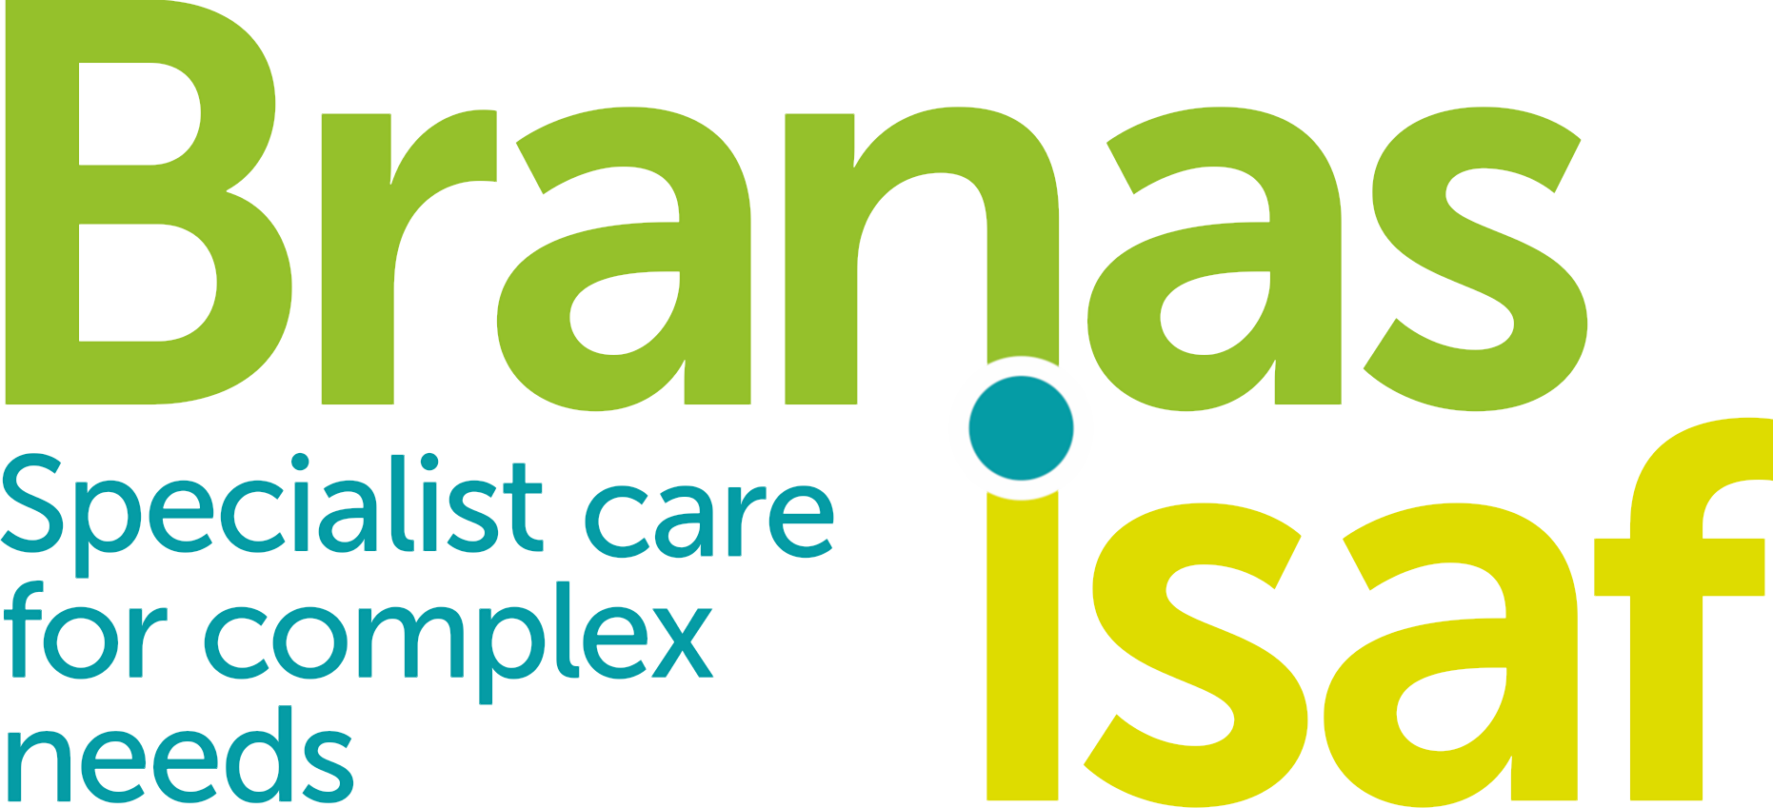

JOB DESCRIPTION & PERSON SPECIFICATION

Practitioner Psychologist (Counselling, Clinical or Forensic).

Job Title: | Psychotherapist / Practitioner Clinical Psychologist / Counselling Psychologist / Forensic Psychologist
Salary: | Up to £44,000 (dependant on experience and qualifications)
Hours: | 37.5 Hours per week
Location: | Branas Isaf – Corwen
Reports to: | Clinical Operations Manager

JOB DESCRIPTION
ROLE OF DEPARTMENT
The clinical team work within the wider integrated team of professionals at Branas Isaf, applying psychological knowledge and expertise to service users and professionals within the group (e.g. education and care staff). Primarily, the clinical team support children and young males aged 10-18 who present with a number of complex interpersonal, emotional and behavioural issues a number of the young people within our care have experienced significant trauma.

The clinical team are responsible for:
- Providing a specialist psychology service for all clients of the service.
- Providing psychologically informed consultation to teams, training and assisting with service development.
- Conducting psychometric and risk assessment and developing formulations.
- Providing and evaluating individual and group-based interventions (including Dialectical Behavioural Therapy).
- Providing specialist psychological research expertise to the service.

CLINICAL TEAM STRUCTURE
CLINICAL OPERATIONS MANAGER
SENIOR PSYCHOTHERAPIST
Practice Supervision- 1, 2, 3

SENIOR PSYCHOLOGIST
Practice Supervision - Practitioner/ Assistant Psychologist

PSYCHOTHERAPIST 1
CORWEN

PSYCHOTHERAPIST 3
HIDELOW

P/T (3 days) PSYCHOTHERAPIST 2
CORWEN

HONARARY ASSISTANT PSYCHOLOGIST
UNPAID
WGU
F/T PRACTITONER PSYCHOLOGIST
Burly Farm

F/T ASSISTANT PSYCHOLOGIST

MAIN DUTIES/RESPONSIBILITIES
Clinical
- To contribute to psychological assessment and formulation of individuals and groups, for example through direct observation, psychometric testing, semi-structured interviews and writing appropriate reports.
- To provide individually tailored psychological interventions to meet the needs of allocated clients.
- To support the integrated team to implement programmes arising from such assessment and individually tailored psychological interventions.
- To provide written assessments/reports in a timely manner and/or contribute to MDT reports and attend meetings as required.
- To monitor and evaluate programmes and advise managers when problems and difficulties arise.
- To be actively involved in the weekly Dialectical Behavioural Therapy (DBT) consult team meetings, DBT skills group and contribute to monitoring fidelity to the treatment model.
- To contribute to the management of risk with the wider integrated team.
- To ensure appropriate confidentiality.
- To liaise with Registered Managers, education staff and other members of the multi-agency team, including external professionals.
- To represent the clinical team within external and in-house meetings (where appropriate).
- To engage flexibly with clients and other members of the integrated team at Branas Isaf, families and multi-agency team to promote constructive working relationships. This may include out of normal hours work.

Teaching, training and supervision

- To prepare and participate in supervision and appraisal as stipulated within the policies and procedures.
- To take responsibility for ongoing learning and development, including full participation in clinical and line management supervision and appraisals, in order to maximise own potential and continue to meet the demands of the post.
- To contribute to the development and delivery of teaching, training and support of other staff at Branas Isaf.
- To participate in external and internal training as deemed appropriate.
- To attend and contribute to regular team meetings and CPD days.
- To contribute to the development and maintenance of the highest professional standards of practice, through active participation in internal and external CPD training and development programmes, in consultation with the post holder’s manager.

Research and service evaluation

- To assist in the design and implementation of research, service evaluation or audit activities.
- To undertake data collection, analysis, the production of reports and summaries, using IT and statistical packages.
- To undertake database searches for literature and research papers to inform evidence-based practice for the clinical team.

General
- To know where to access existing Branas Isaf and Care Tech policies and procedures are and to be aware of and follow their contents, and to contribute to the development of new policies as appropriate.
- To adhere to Branas Isaf codes of conduct, policies and policies, as well as legislation relevant to the organisation and job role.
- Competence in the use of internet systems and information technology is essential.
- To maintain the highest standards of clinical record keeping and report writing in accordance with your professional registering/accrediting body and organisational policies and procedures.
- To maintain other records as required within the Clinical Team Framework (3.2 Branas Isaf Policies and Procedures).
- All employees of Branas Isaf and Care Tech are legally responsible for all records held, created or used as part of their employment including clients, corporate and administrative records whether paper based or electronic and also including emails. All such records are public records and are accessible to the general public, with limited exception, under the Freedom of Information Act 2000, the Environmental Information Regulations 2004 and the Data Protection Act 2018.
- Ensure that Branas Isaf and Care Tech's policy on equality of opportunity is promoted through his / her own actions and those of any staff for whom he / she has responsibility.
- Co-operate fully with the implementation of Health and Safety arrangements, reporting any accidents / incidents / equipment defects to his / her manager and maintaining a clean, uncluttered and safe environment for patients / clients, members of the public and staff.
- Represent Branas Isaf and Care Tech's commitment to providing the highest possible standard of service to patients / clients and members of the public, by treating all those with whom he / she comes in to contact in the course of work, in a pleasant, courteous and respectful manner.
- Adhere at all times to all Branas Isaf and Care Tech policies / codes of conduct, including for example:
- Smoke Free policy.
- I.T. Security Policy and Code of Conduct.
- Standards of attendance, appearance and behaviours.
- Safeguarding.
- Understand that this post may evolve over time and that this Job Description will therefore be subject to review in the light of changing circumstances. Other duties of a similar nature and appropriate to the role may be assigned from time to time.
- It is a standard condition that all Branas Isaf and Care Tech staff may be required to serve at any location within the assigned region, as the needs of the service demand.
- To carry out, as and when required, any additional tasks and responsibilities as are reasonably compatible with this job description and its objectives.

PERSON SPECIFICATION
KNOWLEDGE, TRAINING AND EXPERIENCE REQUIRED

Essential Criteria
These are criteria all applicants MUST be able to demonstrate either at short listing or at interview. Applicants should therefore make it clear within their application whether or not they meet these criteria. Failure to do so may result in you not being short listed.

 | ESSENTIAL | DESIRABLE
TRAINING & QUALIFICATIONS | - Practitioner Counselling / Forensic Psychology / Clinical Psychology qualification(s).  Masters / Post Graduate Psychotherapy Qualification in a talking therapy, e.g. Cognitive Behavioural Psychotherapist (LEVEL 2), Masters Level Psychotherapist.  - To be considered for this role you must have HCPC registration as a practitioner psychologist and are likely to also be a Chartered psychologist and a full member of the appropriate division of the BPS or a registered member of the BACP/UKCP or other recognised association. You will fully observe the BPS/BACP/UKCP code of conduct and keep up-to-date with developments in the field of psychology and therapy to ensure you meet the continued professional development requirements for the post. | - Attended training in Dialectical Behavioural Therapy (DBT) or be willing to attend DBT training on appointment.  - Eye Movement Desensitization and Reprocessing (EMDR).  - Dyadic Developmental Psychotherapy (DDP).
EXPERIENCE | - Paid or voluntary experience (including during training) in psychology / psychotherapy. | - Experience of working with children / adolescents and their families or carers.  - Previous experience as a Psychologist or Psychotherapist.  - Previous experience working within a DBT consult or facilitating DBT groups.
KNOWLEDGE AND SKILLS | - Ability to communicate effectively and both a written and oral level complex, highly technical and clinically sensitive information, to service users, their families, the integrated team within Branas Isaf and a wide range of lay and professional people outside of Branas Isaf.  - Good IT skills with an ability to use word processing, database and statistical software packages. | - Knowledge of relevant legislation and its implications for both practice and professional management in relation the service user group.
PERSONAL | - Ability to maintain a high degree of professionalism in the face of highly emotive and distressing problems.  - Ability to work effectively on own and as a team member.  - Enthusiasm for a broad range of psychological phenomena, and interest in models of service delivery, and an ability to articulate the value added by colleagues from the education and care teams within the context of multi-disciplinary services.  - Ability to contain and work with organisational stress and ability to ‘hold’ the stress of others.  - Hold a current driving licence valid for use within the UK and have, on appointment, access to a car. | - An interest in working with children / adolescents.
OTHER | - Ability to accept and use supervision appropriately and effectively.

Notes to all applicants
- You must clearly demonstrate on your CV and supporting statement how you meet the required criteria, failure to do so may result in your not being short listed. You should clearly demonstrate this for both the essential and desirable criteria.
- Proof of qualifications and / or professional registration will be required if an offer of employment is made - if you are unable to provide this, the offer may be withdrawn.
- As part of the recruitment and selection process it will be necessary for Branas Isaf to carry out an Enhanced Disclosure Check through the Disclosure and Barring Service before any appointment to this post can be confirmed.
- Branas Isaf and CareTech Community Services is an Equal Opportunities Employer.

AGREEMENT
Job Description approved by and signed on behalf of Branas Isaf:
PRINT NAME
SIGNATURE
DATE

Job Description signed as read and understood by employee:
PRINT NAME
SIGNATURE
DATE

